Standards for Mathematical Practice Reference Sheet

Metacognitive Prompts Math Practice 1
Before | During | After
• What is the problem asking?  • What information is needed to solve the problem?  • What information do I know?  • Does this problem remind me of any problems I have solved in the past? If so, what did I do?  • How can I organize this information?  • Do I need to add, subtract, multiply, or divide? Why? | • Is the strategy working?  • Do I need to try another approach?  • Does the answer make sense?  • Explain | • Why did I solve the problem that way?  • What was easy/hard about solving this problem?  • If I got stuck, what did I do to get unstuck?  • Is there another way to solve this problem?
Teacher Reflection Questions
• Do I demonstrate that I value the process rather than simple the correct answer?
• Do I give problems that require perseverance and use questioning to guide and support my students as the problem solve?
• Do I provide students the opportunity to share their work and solutions with a partner, group or the whole class?

How Can Math Practice 2 Be Reinforced in The Classroom?
• Number webs (how many ways can you show 12?) builds flexibility for decontextualizing.
• Writing a word problem (e.g. for 3 x 4) builds contextual fluency.
• Create a word problem that allows students to represent it abstractly and then requires them to us the answer for an appropriate response.
• Encourage students to write about how math plays a role in their own life.
Teacher Reflection Questions
• How do I deepen my students’ understanding of numbers (flexibility) to better understand quantities?
• Am I allowing my students to create their own problems with a real world context?
• Am I challenging my students to make sense of their answers by recontextualizing?

How Can Math Practice 3 Be Reinforced in The Classroom?
• Using an Eliminate Strategy
• Agree or Disagree (Teacher poses a math statement. Students either agree or disagree. Students must include math reasoning to support their argument.)
• Find the Mistake (Students critique faulty work and offer ideas as to why it’s incorrect.)
Teacher Reflection Questions
• Do I give my students an opportunity to listen to others and assess their arguments?
• Do my students back up their arguments with appropriate math reasoning?
• Do I provide opportunities for my students to assess faulty work?

How Can Math Practice 4 Be Reinforced in The Classroom?
Representations | • Part-Whole Modeling for addition and subtraction  • Bar Diagrams
Metacognitive Prompts | • Tell me what your model represents.  • Why did you choose to represent it this way?  • How did creating this model help you?  • Is there another way you might have modeled this problem? How?
Teacher Reflection Questions
• Do I encourage my students to create diagrams to solve problems?
• Do I ask my students why they chose a particular model?
• Do I encourage my students to revise a model if needed?
• Do I have my students write about what they learned from their model?

Considerations for Math Practice 5
Students Ask Themselves | • Am I using the best tool available to help me analyze the problem?  • Is there a better tool I could use to help solve the problem?  • Do I understand why this tool was helpful?  • Can I explain the process to somebody else using this tool?  • Do my results make sense?
Teacher Should Consider | • Choose the tool(s) to support the lesson’s objectives.  • Introduce new tools to students.  • Consider the students when planning the lesson.  • Communication about the use of the tools is the key to the effectiveness of using tools. Ask appropriate questions frequently.  ~ What do the blocks represent?  ~ What number did you start with?  ~ Explain how you decided upon the groupings.  ~ How did you know that three groups of five is 15?  • Connect your students’ thinking to the strategies. The ultimate goal is to move students from concrete to pictorial to abstract. This supports the development of mathematically proficient students.

How Can Math Practice 6 Be Reinforced in The Classroom?
Categorize | • Identify similarities and differences between math concepts.  Sort the following math terms and explain how they are sorted.  • sum, minus, join, subtract, add, take apart, plus  • square, trapezoid, hexagon, rectangle, rhombus, triangle, pentagon  • pint, foot, measuring cup, ounce, inch, scale, yard, pound, quart, ruler
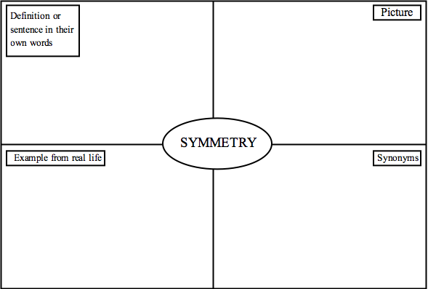
Teacher Reflection Questions
• Do I discuss important math vocabulary and explore word meanings through familiar language, words, pictures, and examples?
• Do I ask students to label units, quantities, and graphs?
• Do I provide opportunities for students to work with partners to formulate explanations?
• Do I expect accuracy unless an estimate is desired?

How Can Math Practice 7 Be Reinforced in The Classroom?
Look for patterns in: | • Hundreds and Multiplication Charts  • Math Properties  • Fraction and Decimal Equivalents  • Fact Families
Teacher Reflection Questions
• Do I ask my students what they notice and wonder?
• Do I give my students opportunities to look for patterns while problem solving?
• Do I model the use of properties in solving problems?
• Do I provide opportunities for my students to discuss and prove math properties?

How Can Math Practice 8 Be Reinforced in The Classroom?
• Provide problems that provide opportunities for students to discover patterns through data collection or making a table.
• Provide combination problems: ~ Bill has 5 shirts and 3 pairs of pants. How many outfits can he make?
Teacher Reflection Questions
• Do I ask students to look for repetition of patterns?
• Do I provide problems that require the collection of data?
• Do I have students look for short-cuts when solving problems?
• Do I encourage risk taking?

